**A**

**Project Report**

**On**

**“Music Institute Management System”**

**Organization Name: Krishnakala Music Institute, Shirpur**

|  |  |  |
| --- | --- | --- |
| *Course Name* | : | **Bachelor of Computer Application**  **(BCA)** |
| *Class* | : | **T.Y.B.C.A.** |
| *Seat No.* | : | **852391** |
| *PRN No. of Student* | : | **2016015400349196** |
| *E-Mail id of Student* | : | [**sunnysonawane25@gmail.com**](mailto:sunnysonawane25@gmail.com) |
| *Mobile No. of Student* | : | **8855998508** |
| *College Name* | : | **R. C. Patel Arts, Commerce and Science College, Shirpur, Dhule** |
| *College Code* | : | **240051** |
| *Academic Year* | : | **2018-19** |
| *Project Guide Name* | : | **Mr. Rahul A. Mali** |
| *Mobile No. of Guide* | : | **7588318584** |
| *E-Mail id of Guide* | : | **Rahulmali625@gmail.com** |

PROJECT REPORT

ON

“Music Institute Management System”

For

“Krishnakala Music Institute, Shirpur”

### Submitted By

**Sonawane Darshan Pandharinath**

## Guided by

**Mr. Rahul A. Mali**



**R. C. Patel Arts, Commerce and Science College,**

**Shirpur, Dhule-425405**

**Department of Computer Application**

**Submitted to**

**K. B. C. North Maharashtra University, Jalgaon.**

**2018-19**

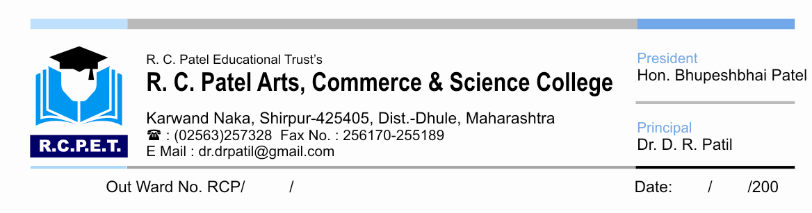

***CERTIFICATE***

This is to certify that student **Sonawane Darshan Pandharinath** of **T.Y.B.C.A.** has completed Project Title as “**Music Institude Management System**” for **Krishnakala Music Institute, Shirpur** under the guidance of **Mr. Rahul A. Mali** during the academic year 2018-19.

**Date:**

**Place: Shirpur**

**Guide H.O.D**

**Mrs. Rahul A. Mali Prof. S. P. Patil**

**Examiners:**

**1) External : ________________________________**

**2) Internal : ________________________________**

**ACKNOWLEDGEMENT**

It gives me immense pleasure for submitting this project report on “**Music Institute Management System”** for degree course on Bachelor of Computer Application.

I am thankful to my Guide **Mr. Rahul A. Mali,** for valuable guidance, kind of suggestion, constant encouragement and excellent co-operation and valuable help.

 I wish to record my deep gratitude and sincere thanks to **Prof. S. P. Patil,** Head of Department, for their kind support, inspiration and timely providing required facilities for the completion of project.

I also express my gratitude and thanks to **Principal Dr. D. R. Patil** R.C.P.A.C.S College Shirpur, for permitted me to carry out this Project.

Last but not the least my sincere thanks to our parents, family members and friends for their continuous support, inspiration and encouragement without which this project would not have been success.

**Mr. Sonawane Darshan Pandharinath**

**(BCA SEM VI)**

**(2018-19)**

**INDEX**

|  |  |  |
| --- | --- | --- |
| **Chapter No** | **Name Of Chapter** | **Page No** |
| **1** | **Introduction** | **1** |
|  | 1.1 Introduction to project |  |
|  | 1.2 Objective of project |  |
|  | 1.3 Scope of project |  |
| **2** | **System Study And Analysis** |  |
|  | 2.1 Information gathering |  |
|  | 2.2 Existing System |  |
|  | 2.3 Drawbacks in existing system |  |
| **3** | **Need Of Computer** |  |
|  | 3.1 Need for system |  |
|  | 3.2 need for computerization |  |
|  | 3.3 Advantages of computerization |  |
|  | 3.4 Introduction to proposed computerization system |  |
|  | 3.5 Advantages of computerized system |  |
|  | 3.6 system security |  |
| **4** | **Feasibility Study** |  |
|  | 4.1 Economical feasibility |  |
|  | 4.2 Technical feasibility |  |
|  | 4.3 Operational feasibility |  |
| **5** | **Hardware/software Requirement** |  |
| **6** | **Reason for selecting VB.net** |  |
| **7** | **Preliminary Design for proposed system** |  |
|  | 7.1 Data designing |  |
|  | 7.2 Input designing |  |
|  | 7.3 Output designing |  |
|  | 7.4 Screen designing |  |
|  | 7.5 Procedural designing |  |
|  | 7.6 Architectural designing |  |
| **8** | **Detail design of proposed system** |  |
|  | 8.1 Detail designing |  |
|  | 8.2 data dictionary |  |
| **9** | **Appendix A** |  |
|  | 9.1 Data entry screens as forms |  |
| **10** | **Appendix B** |  |
|  | 10.1 Sample reports generated by computerized system |  |
| **11** | **Conclusion** |  |
| **12** | **Undertaking** |  |
| **13** | **References** |  |